Personalized Mobile Tour Guide

Software Requirements Specification (Srs) Report
2009-05-23

Table of Contents
Table of Contents 2
List of Figures 3
List of Tables 4
Abbreviations and Acronyms 5
1 Overall Description 6
1.1 Product Perspective: 6
1.1.1 System Interfaces: 6
1.1.2 User Interfaces: 6
1.1.3 Hardware Interfaces: 6
1.1.4 Software Interfaces: 7
1.1.5 Communication Protocols: 7
1.2 Assumptions and Dependency: 7
1.3 Apportioning of Requirements: 7
2 Specific Requirements: 8
2.1 Functional Requirements: 8
2.2 Logical Database Requirements: 9
2.3 Design Constraints: 9
2.4 Other Requirements: 9
2.5 Prioritization of Requirements and Dependencies between them: 9

List of Figures

Figure | `Page Number
Logical database design | 9

List of Tables

Table | Page Number
Prioritization of Requirements | 10

Overall Description
Our product aims to locate the user using different technologies.
By locating him, he can ask about different paths to certain destination and this path will be shown on a map. Also it will suggest means of transportation.
And the website will concern with capturing the user's personal data. The users will register either as individual user this requires him to maintain his personal data, interests and his travel history or register as an organization (service provider) this require to maintain the template of his service. The application can act as a tour guide that leads the user to landmarks and public services and provide him with information about it as he navigates.

Product Perspective:

1.1.1 System Interfaces:
System has two interfaces users can intract through mobile and website
-The application gets the user’s current location via one of these techniques:
- Global Positioning System (GPS).
- Cell phone towers.
- Or entering his position manually.

-By locating you, you can ask about the path to certain destination and this path will be shown on a map.

-Not only one path to your destination will be shown but you’ll have alternative paths and information about each like distance of each.

-Another option you don’t have to own a car our system will recommend some means of transportation that can lead u to your destination like buses, metros stations.

-Our focus for this project is on software support for location based applications; we are not just interested in the location but also other elements of the user’s context, nearby public services (police stations, hospitals).

-Also not just locating these services but provide the user with information about it.

-It can display landmark information. As the user changes locations

-Through our website, we provide the user with the required contact information .( For example, if the user want to contact Egypt air to reserve or confirm a reservation, our website will provide him with the contact information like phone number or website).

-A user's interests are captured in a personal profile, their travel history by giving feedback about items in their travel. When register at our web site and If you don’t want to register your personal data the system will run under default configurations.

-Our system considers the personal background of a traveler both for selecting the information that is delivered to the user and for recommending sights.

-Not only system users who will register on our system but also service providers can register so his service can be displayed for users. (e.g. : if u owns a restaurant and u want our users to know about it u can register and provide the system with data about it and it will display for nearby users).

-The web service provides personal image upload and location blog facility.

-Give virtual tour (location picture) of that location.

-Our website will be provided with security to keep your personal data safe.
-Our application provides relevant tourism scenarios and tourist programs

-It can display the weather conditions of certain location.

-by enabling “Where I am?” user can send his position to a certain number

The application will support different versions of mobile. Some mobile versions can’t display the map, so it has a simple interface instead of maps, knowing the device features, the delivered information can be tailored to the particular hardware and software platform.

User Interfaces:

The mobile device must be Java-Enabled and have an internet access and it must be recent enough to install the application.
About application users, they don’t suffer much as all theyhave to do is having the minimum knowledge to interact with the mobile and web application and also dealing with maps.

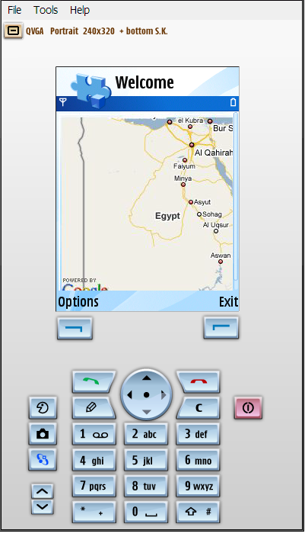
This is the first screen of the application of the application the user would get
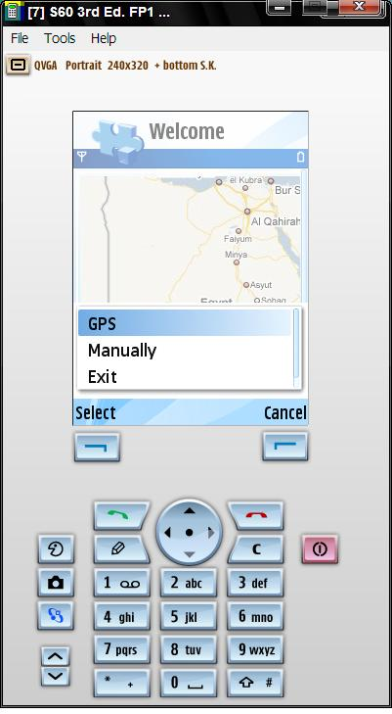
If user chooses to use the GPS then the system will use it to get the longitude and latitude coordinates of the user and visualizes them on a map
If the user chooses to enter his position manually he will be asked to enter his address and the system can visualize the user location on a map

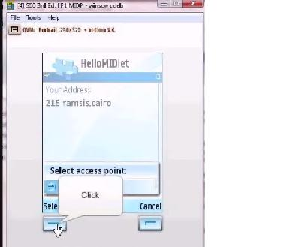
Here the user entered his postion manually

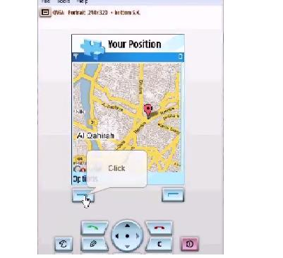
the system visualized user location on a map

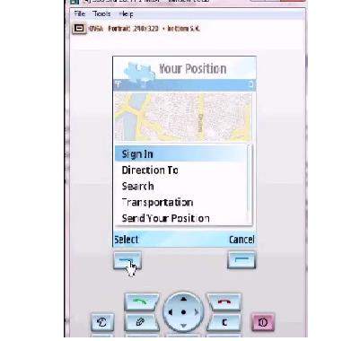
List of options appears to user user can choose to sign in so he can get peronlized data according to info enterd in the website.
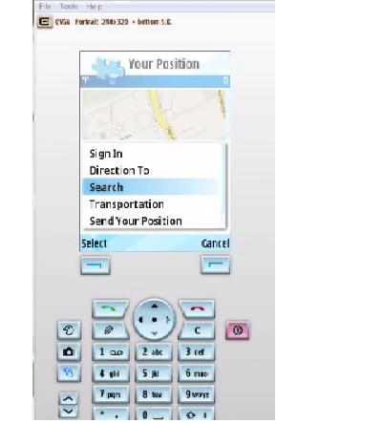
here the user choosed to search for near by service .
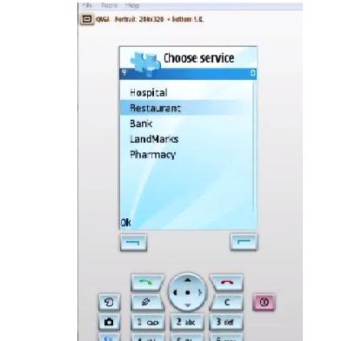
list of categories appeared to him filttered by his personalized data
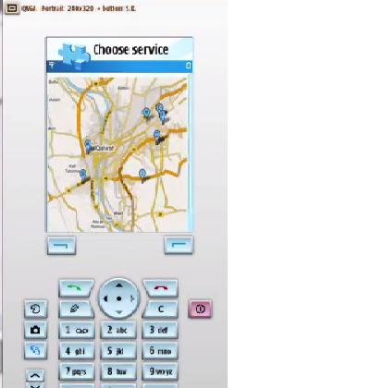
And this screen of all nearby restaurant around him
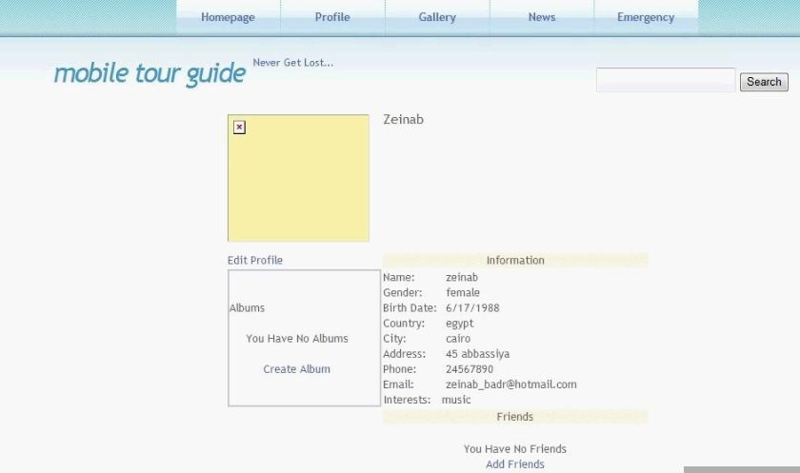
This the website Page where the user can enter his personal data to be captured to use it in retrival from mobile
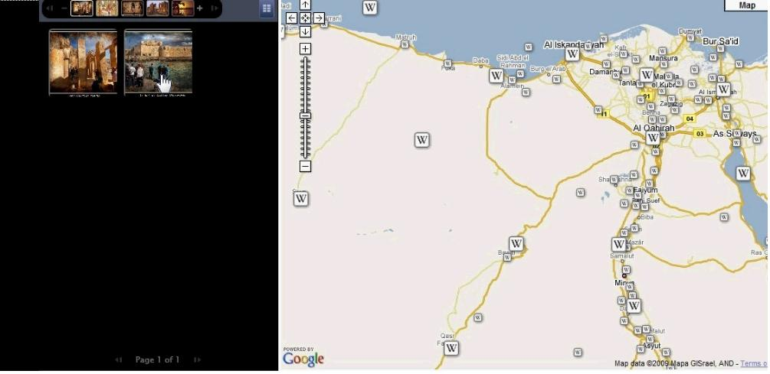
This is where the user can surf the gallery of any where in Egypt this is map which he can choose any where and aphoto of this palce will appear on the left side of the screen ☺

Hardware Interfaces:
Just the mobile has to be GPS enabled to be able to locate and finding pathes.

Software Interfaces:
Our application will use Google maps API for locating and navigating
The Google Maps API lets you embed Google Maps in your own web pages with JavaScript. The API provides a number of utilities for manipulating maps and adding content to the map through a variety of services, allowing you to create robust maps applications.

Communication Protocols:
- The WCF technology will be used to enables the mobile application and website to connect to the database through webservice it enables a connection that provides transport data to mobile device and website through the use of the Http Binding. This binding is based on a traditional HTTP connection.

Specific Requirements:

Functional Requirements:
The system provides set of functions some in the mobile and others in the website
- Mobile functions:
- Locate the user
Description
Use some location techniques to detect the location of the user as Lang/lat coordinates. A map will be displayed and the position of the user will be marked on it.
- Find path from source and destination
Description
The user requests that he wants to find the path between source and destination. Then the path is drawn on the map.
- Suggest means of transportation
Description
The user can request to know the available transportation from source to destination.
- Search for a service
Description
The user searches for a specific service even nearby services or a public service anywhere.
- Request information about service
Description
When the user chooses specific service the application will display the available information about this place.
- Send my position
Description

Enable the user to send his current location to another user of the application.
- Comment / rate a service

Description

The user can post a comment on a service or rate this service with positive rate or negative rate.
- Website functions:
  - Register in the website
Description

The user at the first time visit the website may register even as an individual user or as a service provider. The user has to fill his personal data in his own profile.
  - Show the Gallery
Description

The user is enabled to watch the gallery of the historical and touristic places which contain pictures about these places and information about it.
  - Search about information
Description

Enable the user to search for information about a specific service or a touristic place.
  - The latest news
Description

Each time the user log in to the website he will be able to have the latest news about services and events.
  - Add his photos

Description

Enable the user to share his photos with other people.

Logical Database Requirements:
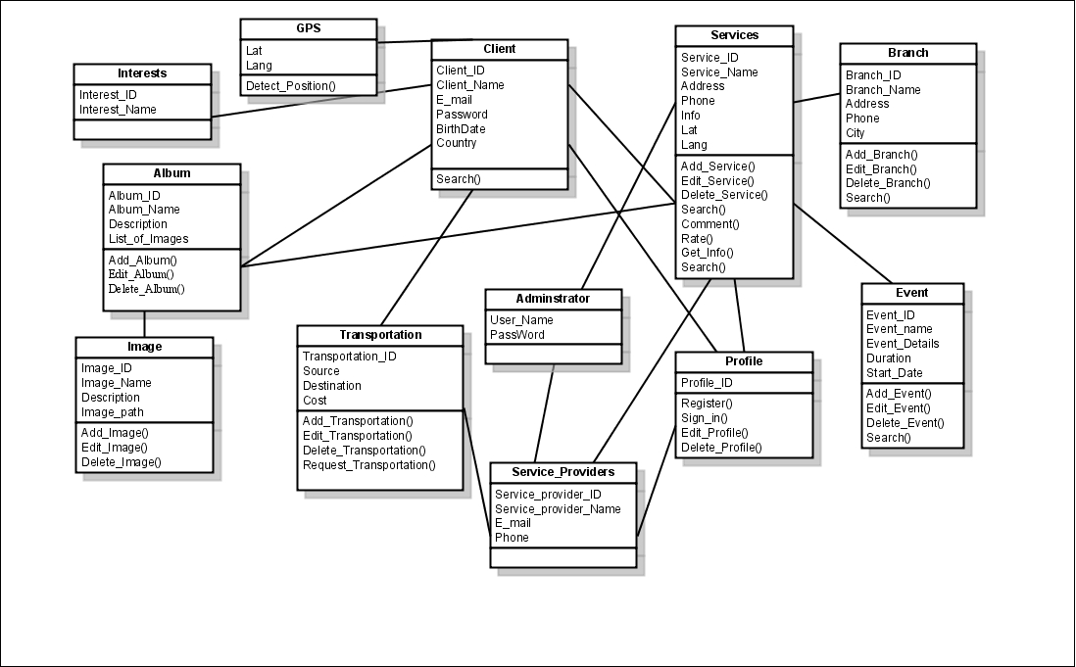

Design Constraints:
According to mobile’s limited capabilities so the application uses static maps instead of dynamic maps as dynamic maps use JavaScript code which is an overhead on the mobile.
The limited memory of the mobile prevents the database to be on the mobile so it is uploaded on server.

Other Requirements:
Security:
Security is required, so WCF is used, to secure data transferred between server and clients.
It acts as Interface between presentation layer (Website, mobile) and the Database layer.
So there is no direct access to the database from the client. Only the server accesses it.

Prioritization of Requirements and Dependencies between them:

Req. Ref. No. | Priority | Dependency Ref. No.
1 | High priority | -
2 | High priority | May depend on 1
3 | High priority | May depend on 1
4 | High priority | -
5 | Medium priority | 4
6 | Low priority | 1
7 | Medium priority | 4
1 | Medium priority | -
2 | High priority | 1
3 | High priority | 1
4 | Medium priority | 1
5 | Medium priority | 1

